To: Danielle Sherman

From: Jennifer Brosnahan

Date: July 19, 2020

Subject: Market Basket Analysis Report

**Project Goals**

The purpose of this project is to conduct a Market Basket Analysis to gain insights on Electronidex’s clientele and try to find patterns or item relationships within Electronidex’s customer transactions. The following questions will be addressed:

1. Are there any interesting patterns or item relationships within Electronidex’s transactions?
2. Would Blackwell benefit from selling any of Electronidex’s items?
3. In your opinion, should Blackwell acquire Electronidex?
4. If Blackwell does acquire Electronidex, do you have any recommendations for Blackwell?

**Initial observations**

The Electronidex online transaction dataset contained 9835 total transactions with 125 total possible products to choose from within a 30-day time span. A summary of transactions was performed and revealed the following observations:

* 43,151 total items were purchased
* Top 5 most frequently purchased items include: iMac, HP Laptop, Cyberpower Gamer Desktop, Apple Earpods, Apple MacBook Air (see Fig. 1 for graph of top 20 items)
* Items per transactions ranged from 0-30
* 7672 transactions included more than 1 item, however, 2163 transactions only included 1 item, indicating potential for cross-selling opportunities
* The average # of items purchased per transaction is 4.4

**Figure 1: Top 20 Electronidex items most frequently purchased**

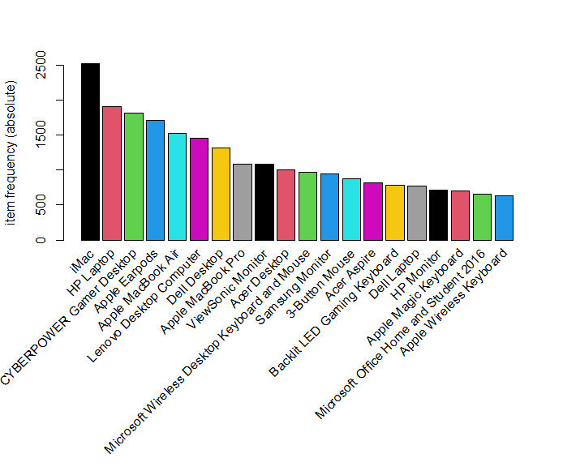

**Interesting discoveries within Electronidex’s transactions (Top Product Relationships)**

A total of 19 top associations is attached to this report in the file ‘Top_Prod_Associations.xlsx’. A summary of the strongest relationships are as follows:

1. Customers who purchase a ViewSonic Monitor with either an Acer Aspire laptop, Dell Desktop, or a CYBERPOWER Gamer Desktop also purchase an HP Laptop.
   * These itemset combinations would serve as an excellent recommendation of items frequently bought together to further boost sales of higher cost items.
2. Monitors (ViewSonic, ASUS 2, ASUS, HP Monitor) are a popular product purchased alongside desktop computers, as seen in 10 of 19 rules.
   * ViewSonic and ASUS 2 are top and would be excellent recommendation items with any desktop computer brand.
3. iMac Desktops are often purchased with 1 or more other desktop computer brands (Lenovo, Dell, Acer), as seen in 1406 total transactions.
   * It is unclear if customers are buying different brands and keeping all, or buying to test out different brands, only to eventually return less desired desktops.
   * In this situation, it would be prudent to first investigate returns of desktops purchased alongside other desktop computer brands listed above. If customers are more often keeping all desktops, then these higher sale transactions could serve as excellent recommendation opportunities of associated products frequently bought together.

**Additional insights**

Electronidex also has low selling items, with the 10 least sold products as follows:

|  |  |
| --- | --- |
| **Logitech Wireless Keyboard** | 22 |
| **VGA Monitor Cable** | 22 |
| **Panasonic On-Ear Stereo Headphones** | 23 |
| **1TB Portable External Hard Drive** | 27 |
| **Canon Ink** | 27 |
| **Logitech Stereo Headset** | 30 |
| **Ethernet Cable** | 32 |
| **Canon Office Printer** | 35 |
| **Gaming Mouse Professional** | 35 |
| **Audio Cable** | 36 |

**Would Blackwell benefit from selling any of Electronidex’s items?**

Many of Electronidex’s items are similar to products in which Blackwell sells (PCs, Laptops, Accessories, Software, Gaming Consoles, and Printers), therefore it is safe to say the clientele for both companies is similar and in need of a retail source for electronics. I believe Blackwell would benefit from selling Electronidex’s top 20 most frequently purchased items not already sold by Blackwell, as well as any item listed within the top product relationships (potential for sales boost).

**In your opinion, should Blackwell acquire Electronidex?**

Within 30 days, Electronidex incurred 9835 total online transactions with 43,151 total items sold. The purchasing of Electronidex would expand Blackwell’s online platform, customer base, and overall growth and sales. I believe Blackwell should acquire Electronidex as long as projected growth in sales and profits surpass cost of buying out Electronidex.

**If Blackwell acquires Electronidex, what recommendations do you have?**

1. Initiate recommender systems for the following products listed within these item sets frequently bought together:
   1. Acer Aspire, ViewSonic Monitor, HP Laptop
   2. Dell Desktop, ViewSonic Monitor, HP Laptop
   3. CYBERPOWER Gamer Desktop, ViewSonic Monitor, HP Laptop
   4. ASUS Monitor, HP Laptop, iMac
   5. ASUS 2 Monitor, HP Laptop, iMac
   6. HP Laptop, Microsoft Office Home and Student 2016, iMac
   7. CYBERPOWER Gamer Desktop, ViewSonic Monitor, iMac
   8. HP Laptop, HP Monitor, iMac
2. Send promotional emails to customers who buy specific products within any of the above item sets a-h, informing them of products likely to be interesting to them.
3. Recommend ViewSonic and ASUS 2 Monitors as items customers also view each time a desktop computer is viewed or added to cart.
4. Investigate returns of desktops purchased within the following Desktop computer item sets. If customers are more often keeping all desktops, then initiate recommender systems and email promotions as items customers frequently purchase together.
   * ASUS 2 Monitor + Lenovo Desktop Computer + iMac
   * Apple Magic Keyboard + Dell Desktop + iMac
   * Dell Desktop + ViewSonic Monitor + iMac
   * Lenovo Desktop + ViewSonic Monitor + iMac
   * Acer Desktop + ViewSonic Monitor + iMac
   * Acer Desktop + Lenovo Desktop + iMac
   * Apple Magic Keyboard + Lenovo Desktop Computer + iMac
   * Acer Desktop + HP Laptop + iMac
   * Dell Desktop + Lenovo Desktop Computer + iMac
   * HP Laptop + Lenovo Desktop Computer + iMac
5. Discount or bundle the 20 lowest selling Electronidex products alongside other items recommended to customers in an effort to liquidate products not selling.

**Conclusion**

This market basket analysis revealed relationships and insightful discoveries amongst Electronidex’s product transactions. If Blackwell acquires Electronidex, the insights and recommendations produced in this report can be utilized to cross-sell products, boost sales of items with relationships to other items, and liquidate low-selling products to help maximize growth and sales revenue.